**Workshop Worksheet Packet:**

**Unlock Leadership Potential and Performance with Emotional Intelligence**

In this workshop, you will use five different worksheets for reflection, exercises, and action plans.

Please print this Workshop Worksheet Packet before the workshop and bring it with you.

**Handout #1: What’s in it for me? Personal Goal for Workshop**

What’s in it for me (WIIFM) Journal.

Understanding what can be gained by improving or developing EQ, write down something that you would like to get out of today’s workshop.

**Handout Journal #2: Emotional Intelligence Self-Awareness Questionnaire**

Think about an interaction between you and someone else in your workplace that did not go as well as you intended.

**Part 1:** Using your reflection, write yes or no pertaining to your behavior and if you think there is room for improvement.

|  |  |  |  |
| --- | --- | --- | --- |
|  |  | **Yes/No** | **Could Improve** |
| 1 | I jumped to conclusions, reacted, and interrupted the speaker to make my point. |  |  |
| 2 | I genuinely asked non-judgmental or clarifying questions. |  |  |
| 3 | I responded defensively. |  |  |
| 4 | I shut down or tuned the person out. |  |  |
| 5 | I noticed the person’s feelings behind their words (body language). |  |  |
| 6 | I was aware of what triggered my emotions. |  |  |
| 7 | I showed empathy or consideration. |  |  |
| 8 | I showed respect through eye contact and was fully attentive to their story. |  |  |
| 9 | I had an accurate idea of how the other person (s) perceived me during the interaction. |  |  |
| 10 | I was conscious of the impact my behavior had on me, the other (s), and my performance in the interaction. |  |  |
| 11 | In general, when I am with someone that is irritated, I am able to adjust my behavior to work with them. |  |  |
| 12 | In general, when I feel a strong impulse to do something, I usually  pause to reflect and decide whether I really want to act on it. |  |  |

**Part 2: You will complete later:** Reflection - Think about the items above and how your immediate emotions and reaction may have affected the dialogue and outcome. What is your greatest takeaway from this exercise? ____________________________________________________________________________________________________________________________________________________________________________________________________________________________________________________________________________________________________________________________________________________________

Without awareness of our emotions and how they alter the way we react and take actions can derail effective leadership, team, and organizational outcomes. The questions above are indications of EQ or lack thereof. Being aware of emotions that trigger behavior, understanding others, actively listening, and showing respect are some of the most important skills a leader can possess. How well a person can control emotions and behavior (self-manage, be self and socially aware) has a major impact on their ability to effectively communicate, engage people, understand different perspectives, exhibit empathy, and deescalate conflict, which is integral to emotional intelligence, productivity, performance, healthy personal relationships, and community-building efforts.

**EQ Handout #3: Good Leader, Bad Leader Exercise**

1. Think about some of the best leaders you’ve worked with. Consider the behaviors and qualities that make them good and how others responded to them. Take one minute to write down on the left side as many good behaviors and qualities as you can think of.

|  |  |  |
| --- | --- | --- |
| Good Leader |  | Bad Leader |
|  |  |  |

1. Then on the right side, consider the worst leader you’ve experienced. Write down on the right side: What made them bad? How did others react to them?
2. In your list above, take a moment to circle the good behavior and qualities you would like to add to your leadership repertoire and put an X by any of the poor qualities you would like to exhibit less of.



**Handout Journal #5: Awareness and Benefits of Emotional Intelligence in Others**

Think about and reflect upon past new hires. Was there anyone that you would have benefited from by assessing their EQ Skills before hiring? What area do you feel was lacking?

Reflect upon the benefits of developing or improving EQ. Think of someone in your organization that exhibits strengths but shows up short from one or more of the EQ skills and could benefit from coaching.

Name:

What area (s) do you see as an opportunity and how do you think this could benefit the individual and the team?

**EQ Handout #6: EQ Action Plan for Professional Growth**

Choose one subscale that you would like to personally improve. Emotional self-awareness and empathy action items have been provided, or you can choose another area if you prefer.

Subscale: ________________________

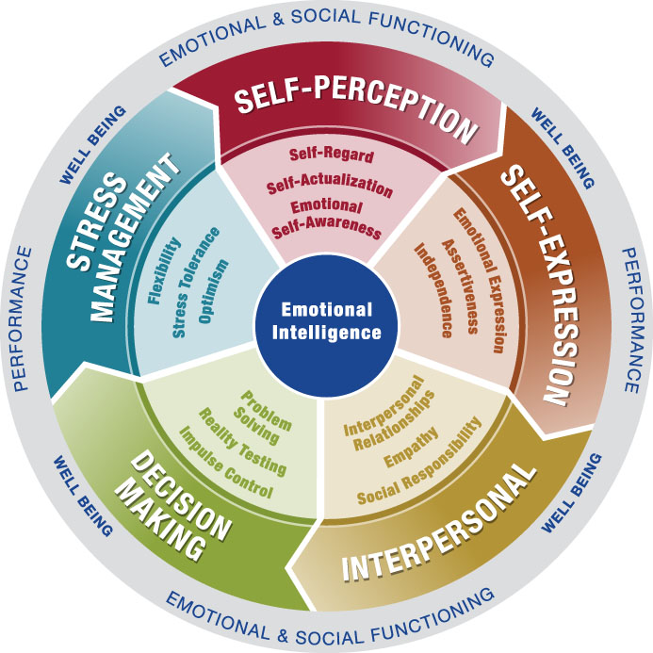

1. Write down the type of situation where this is the biggest challenge for you and the impact change could have.
2. Develop 3 concrete actions you will do differently going forward to practice for the next 4-6 weeks (you can review ideas at the end of this handout). Add the positive impact each will have.
   1. Action Step #1:
   2. Action Step #2
   3. Action Step #3

**When time permits:**

* 1. What emotion shows up with this challenge? Were you fearful/afraid, happy/joyous, sad, angry, surprised, disgusted, or ashamed?
  2. What triggers this or evoked the emotion (and who)? Ask yourself why.
  3. Journal your experience with the practice. What went well, what didn’t go well, and what could you do more of or differently going forward? Be kind to yourself, you will stumble as you make strides for improvement.
  4. Seek an EQ Mentor (someone with the skill you want to develop), Coach, or Accountability Partner (that is not emotionally involved in the situation). Ask if they will help support you and provide genuine feedback. Whom will that be?
  5. Set a weekly meeting date and time to meet. Stick to your schedule if at all possible.

Practice for at least 4-5 weeks before moving on to another goal.

If you are cloudy on this, seek input from someone unemotionally involved in this situation. Whom would that be?

Actions to Develop EQ in Self-Awareness and Empathy

